THE UNIVERSITY OF AZAD JAMMU & KASHMIR, MUZAFFARABAD


COURSE TITLE | DSA
COURSE CODE | CS-2101
LAB TITLE | BINARY TREE
STUDENT NAME | HASEEB SHEIKH
STUDENT ROLL NUMBER | 2024-SE-31
INSTRUCTOR NAME | ENGR. ASMA JAVED
SUBMISSION DATE | JAN 09, 2025

DEPARTMENT OF SOFTWARE ENGINEERING
DSA
Lab 8
Objective
To understand the implementation of a non-linear data structure (Binary Tree) in C++, including node creation and tree traversals (In-order, Pre-order, Post-order).
Binary Tree
A Binary Tree is a hierarchical data structure in which each node has at most two children. Unlike arrays or linked lists, which are linear (items are stored sequentially), trees are non-linear and organize data in levels.
Key Terminology
- Root: The topmost node of the tree. It has no parent.
- Parent Node: A node that has child nodes connected to it.
- Child Node: A node connected to a parent. In a binary tree, these are specifically called the Left Child and the Right Child.
- Leaf Node: A node with no children
Implementation
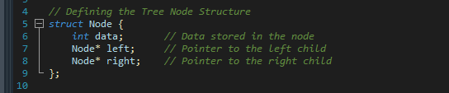
Node Structure:

- Data Container (int data): This variable holds the actual information or value (like numbers 1, 2, or 3) for the specific node.
- Structural Links (Node* left, Node* right): These are pointers that store the memory addresses of the child nodes, connecting the current node to its children (or pointing to NULL if no children exist).

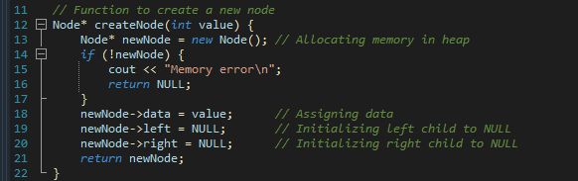
Creating a new node:

In Order Traversal:
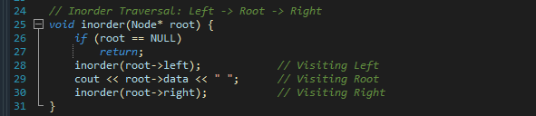

Pre-Order Traversal:
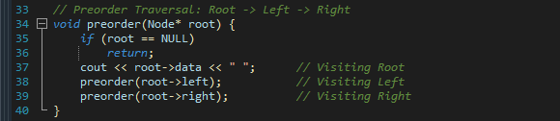

Post-Order Traversal:
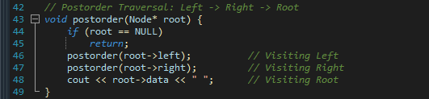

Main Function:
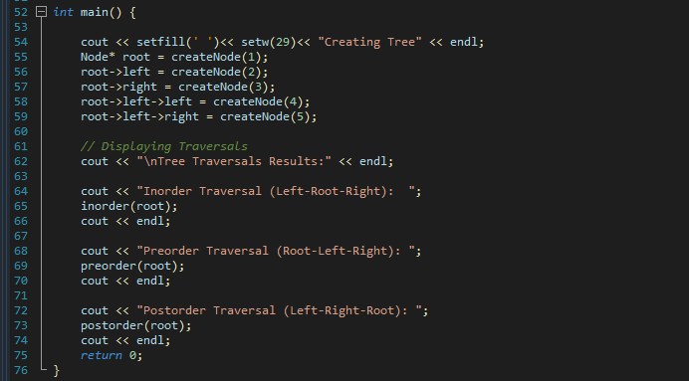

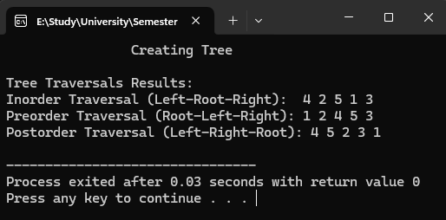
Output:

